Operating Systems

Dr. Rana Asif Rehman

CS2006

Lecture 9

Threads

1st March 2023

1 CS-2006 Operating Systems

1

Background

Basic concepts

■ Multiprogramming: Many processes one CPU. Interleaving between multiple processes. Process relinquish CPU itself.

■ Multiprocessing: refers to more than one CPU. Systems can be both multiprogramming and multiprocessing at the same time.

■ Multitasking: refers to modern operating systems doing preemption for switching processes/threads. OS gives a time quantum to each process/thread.

■ Time sharing: When CPU time is being shared between processes, it is called time sharing system. Multiprogramming & multitasking systems are time sharing systems.

■ Multithreading: is an execution model that allows a single process to have multiple code segments (threads) that run concurrently within the context of that process.

3

Motivation

■ Most modern applications are multithreaded Threads run within application  Multiple tasks with the application can be

implemented by separate threads  MS Word

 One thread for spell checking

 One thread for output of keystrokes  Process creation is heavy-weight while thread creation is light-weight

■ Increases efficiency

■ Kernels are generally multithreaded

4

Introduction

■ Each process has

1. Own Address Space

2. Single thread of control

■ A process model has two concepts: 1. Resource grouping

2. Execution

■ Sometimes it is useful to separate them5 CS-2006 Operating Systems

5

Unit of Resource Ownership

■ A process has an

■ Address space

■ Open files

■ Child processes

■ Accounting information

■ Signal handlers

■ If these are put together in a form of a process, can be managed more easily

6 CS-2006 Operating Systems

6

Unit of Dispatching

■ Path of execution

■ Program counter: which instruction is running

■ Registers:

 holds current working variables

■ Stack:

 Contains the execution history, with one entry for each procedure called but not yet returned

■ State

■ Processes are used to group resources together  Threads are the entities scheduled for execution on the CPU Threads are also called lightweight process (LWP)

7 CS-2006 Operating Systems

7

Its better to distinguish between the two conceptsUnit of Resource Unit of Dispatch

s

s

e

c

o

r

p

t

h

g

i

e

w

y

v

a

e

H

Address

Address

space/Global

Variables

Open files

Child processes Accounting info Signal handlers Program counter Registers

In case of multiple

Stack

threads per process

State

Split

Program

Counter

space/Global Variables Open files

Program

Registers Counter

Stack

Registers Program

State

Child processes Accounting Info

Stack

Counter State

Share

Signal Handlers

8 CS-2006 Operating Systems

RegistersStack

State

8

Multithreaded Server Architecture

9

What are threads?

Thread

■ A thread is a flow of execution through the process code.  A thread will always belong to some process.  A process can have multiple threads but starts with one only Threads share:

■ Same data as that of its process

■ Same code as that of its process

■ Same files as that of its process

■ Each thread has its own

■ Register.

■ Stack.

■ Program Counter.

11

Single and Multithreaded Processes

|  |
| --- |

12

Benefits

■ Responsiveness – may allow continued execution if part of process is blocked, especially important for user interfaces

■ Resource Sharing – threads share resources of process, easier than shared memory or message passing

■ Economy – cheaper than process creation, thread switching lower overhead than context switching

■ Scalability – process can take advantage of multiprocessor architectures

13

Process vs. Thread

■ Process is heavy weight or

■ Thread is light weight, taking

resource intensive.

■ Process switching needs interaction with operating

lesser resources than a process.

system.

■ Thread switching does not need to interact with operating system.

■ In multiple processes each

process operates

■ One thread can read, write or

independently of the others.

change another thread's data.

14

Thread Properties

Multicore Programming

■ Multicore or multiprocessor systems offer real speed up if multiple threads are used

■ Programmers must accurately use threads  Divide independent problems and assign to threads  Keep a balance in dividing activities, do not overburden one or more threads

■ Split Data too, so threads can work in parallel

■ Data should be split properly, so that dependency among threads remains minimum  Testing and debugging of the multi threaded applications is difficult

■ Parallelism implies a system can perform more than one task simultaneously  Concurrency enables more than one task making progress

16

Concurrency vs. Parallelism Concurrent execution on single-core system:

■ Parallelism on a multi-core system:

17

■ Types of parallelism

■ Data ~~parallelism~~ – ~~distributes subsets of thesame data across multiple cores, same operation~~~~on each~~  Task ~~parallelism~~ – ~~distributing threads across~~~~cores, each thread performing unique operation~~

Multicore Programming (Cont.)  As # of threads grows, so does architectural

support for threading

■ CPUs have cores as well as hardware threads

■ Consider Oracle SPARC T4 with 8 cores, and 8hardware threads per core 18 CS-2006 Operating Systems

18

■ User threads - management done by user-level threads library Kernel threads - ~~Operating System managed threads acting on kernel~~

■ Examples – virtually all general purpose operating systems, including:

User Threads and Kernel Threads

■ The thread library contains code for creating and destroying threads, for passing message and data between threads, for scheduling thread execution and for saving and restoring thread contexts  Three primary thread libraries:

■ POSIX Pthreads

■ Windows threads

■ Java threads

■ Windows

■ Solaris

■ Linux

■ Tru64 UNIX

■ Mac OS X

19

User-Level Thread Implementation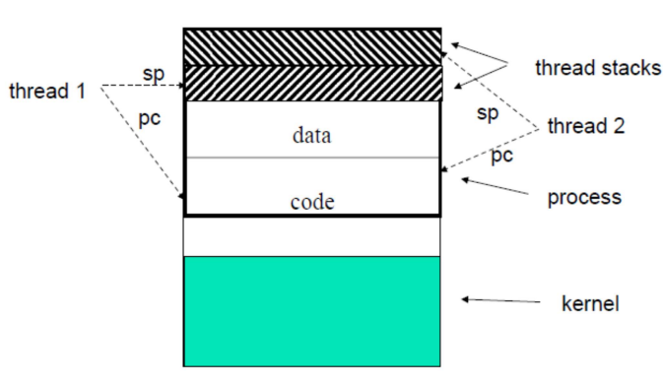20 CS-2006 Operating Systems

20

User-Level vs. Kernel-Level Threads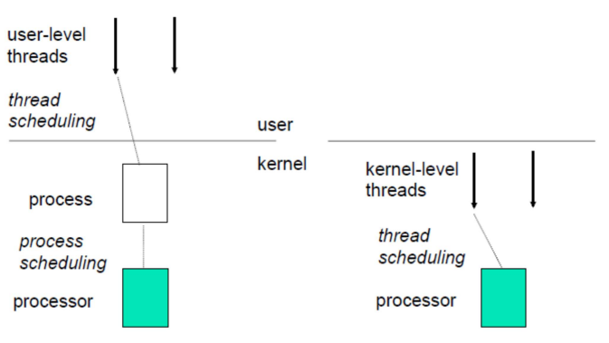21 CS-220 Operating Systems

21

User-level threads vs. kernel-level threads

■ User-level threads are faster to

■ Kernel-level threads are slower

create and manage.

to create and manage.

■ Implementation is by a thread

■ Operating system supports

library at the user level.  OS doesn’t recognize user

creation of Kernel threads.

level threads.

■ OS recognizes kernel-level threads

■ Multi-threaded applications

■ Kernel routines themselves

cannot take advantage of

can be multithreaded.

multiprocessing  If one user level thread

■ If one kernel thread perform blocking operation then

perform blocking operation then entire process will be blocked.

another thread can continue execution.

22

Multithreading Models

User-level threads can be implemented using any of the three models:

■ Many-to-One

■ One-to-One

■ Many-to-Many

23

~~parallel on muticore system because~~

Many-to-One

■ Synonym of user-level threads  Many user-level threads mapped to single kernel thread

■ One thread blocking causes all to block

■ Multiple threads may not run in

only one may be in kernel at a time  Few systems currently use this

model

■ Examples:

■ Solaris Green Threads

■ GNU Portable Threads

24

One-to-One

■ Creating a user-level thread creates a kernel thread More concurrency than many-to-one  One user-level thread is mapped onto one kernel level thread.

■ Even if one thread is blocked, others will still run  Allows multiple threads to run on multiprocessor system Number of threads per process sometimes restricted due to overhead  Examples

■ Windows

■ Linux

■ Solaris 9 and later

25

Many-to-Many Model

■ Allows many user level threads to be mapped to many kernel threads  The number of kernel level threads maybe equal to or less than user

level threads

■ Allows the operating system to

create a sufficient number of

kernel threads

■ Many-to-one: suffered from lack of concurrency

■ One-to-one: suffered from

overhead of too many kernel level

threads

■ Many-to-many suffers from none

26

Threads In Action

C function call vs. thread creation

int x; ---

int x; ---

12

12

---

function()

3

4

---

pthread_create() 2

28

Creating a new thread

int pthread_create(

pthread_t *thread,

const pthread_attr_t *attr,

void *(*start_routine) (void *), void *arg); int pthread_join(

pthread_t thread, // thread to join void **value_ptr // store value returned by thread);

int pthread_exit (void *retval); int pthread_attr_init(pthread_attr_t *attr); int pthread_attr_destroy(pthread_attr_t *attr); unsigned int sleep(unsigned int seconds);

29

Practical work (explanation) pthread_create(pthread_t* , NULL, void*, void*)

■ First Parameter is pointer of thread ID it should be different for all threads.

■ The second argument points to a pthread_attr_t structure whose contents are used at thread creation time to determine attributes for the new thread. Null means use default attr.

■ Third parameter is address of function which we are going to use as thread.

■ Forth parameter is argument to function. Only one is allowed.

30

Practical work (explanation)

pthread_join(i pthread_t , void**)

Pthread join is used in main program to wait for the end of a particular thread.

■ First parameter is Thread ID of particular thread

■ Second Parameter is used to catch return value from thread.

31

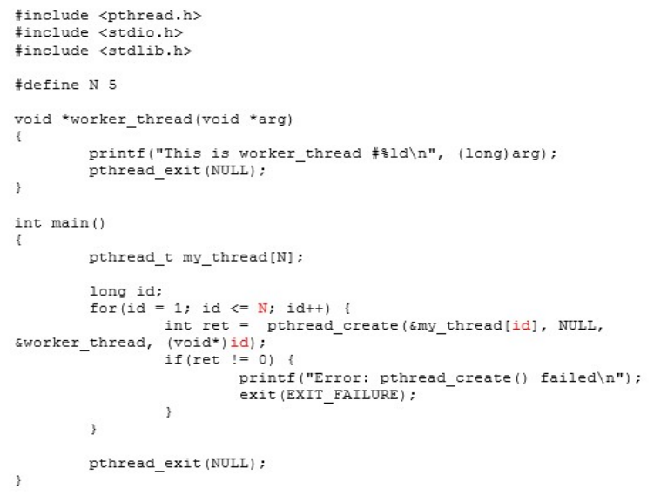32

Output

This is worker_thread #1 This is worker_thread #2 This is worker_thread #3 This is worker_thread #4 This is worker_thread #5

33

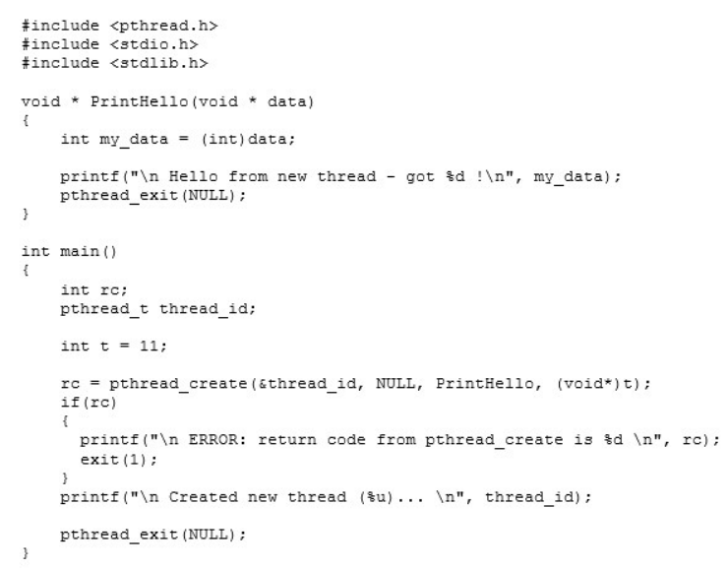34

~~Hello from new thread - got 11~~

Output

Created new thread (4) ...

35

Questions

■ What happens when a thread calls an exit() function?

■ Can a function that is a part of the program be called from a thread?

■ What happens when you call a fork() in a thread?

■ What happens when you call pthread_exit() in the main thread?

36

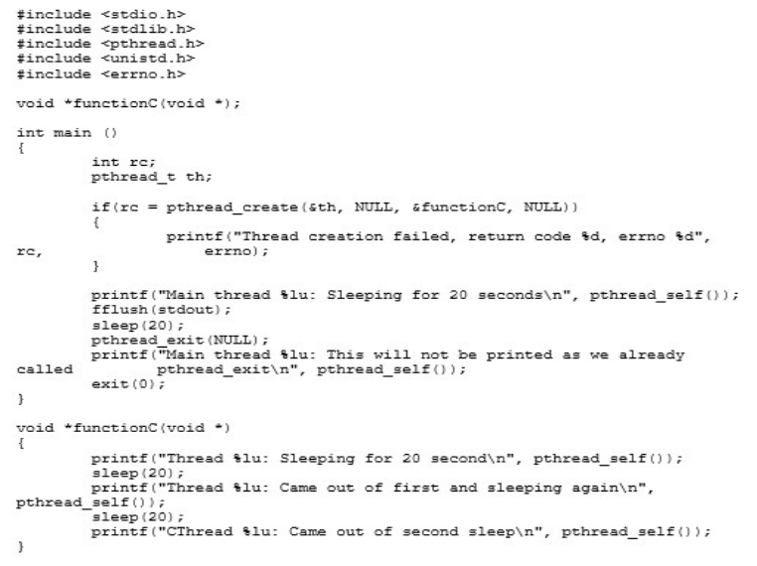37

Output

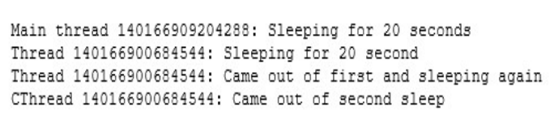38

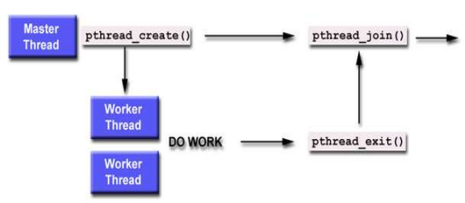39

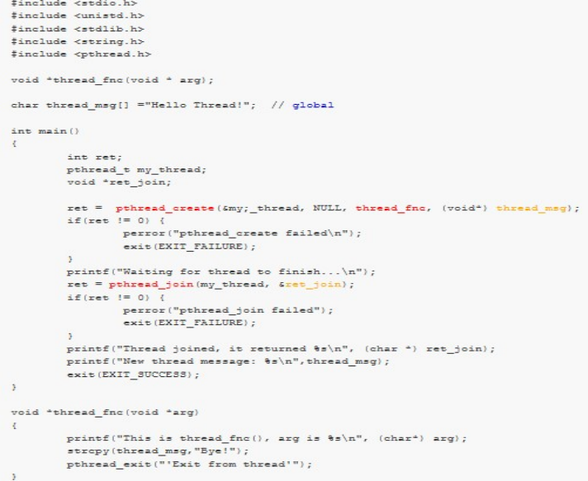40

Output

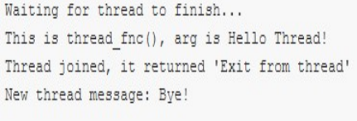41

Practice Problem

Write a program in which you are going to create a thread. The main thread will pass an integer value N to the newly spawned thread. This thread will sum the numbers starting from 1 till the number N. The main thread will display the updated sum. Remember that the main thread will have to wait for the spawned thread to complete its work. SKELETON:

int sum;

void *runner(void *param);

main()

{

pthread_create(tid, attr, runner, int_arg); Pthread_join(tid);

}

void * runner(void *param)

{

sum…

pthread_exit(sum);

}

42

pthread_t tid; /* the thread identifier */

Thread example

pthread_attr_t attr; /* set of thread attributes */if(argc != 2){

fprintf(stderr,"usage: a.out <integer value>\n");

#include <pthread.h>

#include <stdio.h>

int sum; /* this data is shared by the thread(s) */

void *runner(void *param); /* threads call this function */

int main(int argc, char *argv[]) {

return -1;

}

43

Thread example cont.

if (atoi(argv[1]) < 0) {

fprintf(stderr,"%d must be >= 0\n",atoi(argv[1]));return -1;

}

/* get the default attributes */ pthread_attr_init(&attr); /* create the thread */

pthread_create(&tid,&attr,runner,argv[1]);/* wait for the thread to exit */ pthread_join(tid,NULL);

printf("sum = %d\n",sum); }

44

int ~~i, upper = atoi(param);~~ for (i ~~= 1; i <= upper; i++)~~

Thread example cont

/* The thread will begin control in this function */void *runner(void *param) {

sum = 0;

sum += i;

pthread_exit(0);

}

How to run: ./program 5

Expected output: 15

45

Practice

■ Write a program that gets the following problem solved in two threads.

■ (3 * 10) + (5 * 4)

■ First half via thread 1 and second half via thread 2

■ Write the program in which you will search for the two halves of an int array for a value, each half using one thread.

46

Non-deliverable assignment  Write a program in which you create a thread that calculates the factorial of a number n that is input by a user. The thread attributes must be changed are:  Scope

■ Scheduling priority

■ Write a program that prints the first 15 numbers(starting from 1-15) each after a delay of one second using threads  Why do we fork when we can thread?

47

~~//agruments that we pass in the function~~  // we create struct if we have to pass multiple argumentsstruct arg_struct {

Solution Practice example_1 1/5int arg1;

#include <iostream>

int arg2;

#include<pthread.h>

#include<stdio.h>

using namespace std;

#include <string.h>

};

48

{~~struct arg_struct *args = (struct arg_struct *)arguments;~~ int *new_ptr=new int;

Solution Practice example_1 2/5

//function that we use in threads

void* myFunc(void* arguments)

*new_ptr=args->arg1*args->arg2;

pthread_exit( (void*) new_ptr);

//do not use exit routine, it will terminate the whole process}

49

int main()

~~pthread_t thread1_id,thread2_id;~~

struct arg_struct thread1_var;

Solution Practice example_1 3/5struct arg_struct thread2_var;

{

// creating id for thread

//initializing variables

thread1_var.arg1=3;

thread1_var.arg2=10;

thread2_var.arg1=5;

thread2_var.arg2=4;

50

Solution Practice example_1 4/5

// creating threads

if (pthread_create(&thread1_id, NULL, &myFunc,(void *) &thread1_var)==-1)

{

cout<<"Thread Creation Failed!"<<endl;

return 1;

}

if (pthread_create(&thread2_id, NULL, &myFunc,(void *) &thread2_var)==-1)

{

cout<<"Thread Creation Failed!"<<endl;

return 1;

}

51

~~int *ptr_t1_ret,*ptr_t2_ret;~~

Solution Practice example_1 5/5

// variables to store the return value

// wait for the end of a particular thread pthread_join(thread1_id, (void**) &ptr_t1_ret);pthread_join(thread2_id, (void**) &ptr_t2_ret);// display result

cout<<*ptr_t1_ret + *ptr_t2_ret;

}

52

Example 2

53

~~//agruments that we pass in the function~~

// we create struct if we have to pass multiple arguments

Solution Practice example_2 1/5struct arg_struct {

int array[10]={1,2,3,4,5,6,7,8,9,10};

#include <iostream>

int size=10;

#include<pthread.h>

int search=11;

#include<stdio.h>

using namespace std;

#include <string.h>

};

54

Solution Practice example_2 2/5

//function that we use in threads

// to search in 1st half

void* myFunc1(void* arguments)

{

struct arg_struct *args = (struct arg_struct *)arguments; int *val_p=args->array;

int *val=new int;

int i = 0;

for( i = 0; i < args->size/2; i++){

if(val_p[i]==args->search){

*val=val_p[i];

}

}

pthread_exit( (void*) val); }

55

Solution Practice example_2 3/5

// to search in 2nd half

void* myFunc2(void* arguments)

{

struct arg_struct *args = (struct arg_struct *)arguments; int *val_p=args->array;

int *val=new int;

int i = 0;

for( i = args->size/2; i < args->size; i++){ if(val_p[i]==args->search){

*val=val_p[i];

}

}

pthread_exit( (void*) val); }

56

int main()

{~~// createing id for thread~~

~~pthread_t thread1_id,thread2_id;~~

~~struct arg_struct thread_var;~~

Solution Practice example_2 4/5

// creating threads

if (pthread_create(&thread1_id, NULL, &myFunc1,(void *) &thread_var)==-1){

cout<<"Thread Creation Failed!"<<endl;

return 1;

}

if (pthread_create(&thread2_id, NULL, &myFunc2,(void *) &thread_var)==-1){

cout<<"Thread Creation Failed!"<<endl;

return 1;

}

57

Solution Practice example_2 5/5

// variables to store the return value int *ptr_t1_ret,*ptr_t2_ret;

// wait for the end of a particular thread pthread_join(thread1_id, (void**) &ptr_t1_ret); pthread_join(thread2_id, (void**) &ptr_t2_ret);

// display result

if(*ptr_t1_ret>0){

cout<<"found in first half of array"; }

else if(*ptr_t2_ret>0){

cout<<"found in 2nd half of array"; }

else

{cout<<"not found";}

}

58

Thanks

59